**[Crunchy Salt & Vinegar Chickpeas. {Recipe}](http://www.elephantjournal.com/2015/03/crunchy-salt-vinegar-chickpeas-recipe/)**

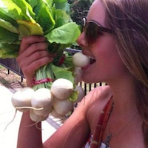

Via [Alli Sarazen](http://www.elephantjournal.com/author/alli-sarazen/" \o "Posts by Alli Sarazen)on Mar 6, 2015

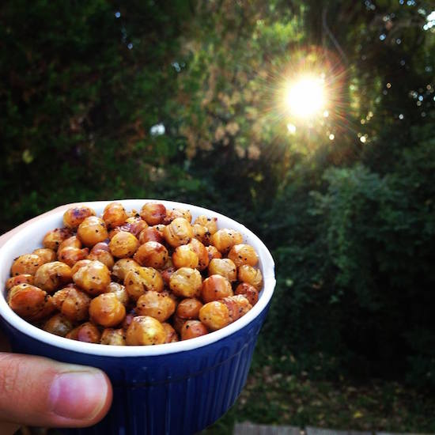

I love salt and vinegar chips.

And for some reason unbeknownst to me (just kidding—biology) they always make me feel kind of icky after I eat them.

So, in an effort to keep showing my body some love with what I put into it, I’ve decided to break up with that dollar bag of breakouts and instead indulge in a protein packed bowl of salt and vinegar chick peas.

Tangy, savory, crunchy, healthy—win.

While these are a bit more labor intensive than popping open a plastic bag, I promise they’re just as satisfying (plus, no plastic packaging involved—double win).

**Ingredients:**

1 can rinsed and drained chickpeas

2 cups white vinegar

sea salt

olive oil

**Utility:**

An oven

A pot

An oven-safe baking pan

An appetite

**Method:**

Put chickpeas, vinegar and a dash of salt into a pot and bring to a boil. Remove immediately, once it starts boiling, and let legumes soak for 40 minutes in the warm vinegar.

Preheat oven to 400°F. After 40 minutes, drain chickpeas of excess vinegar (save the extra fluid for your next batch, because I promise you’ll be making more).

Place chickpeas on oven safe baking pan. Coat with 3 tablespoons olive oil and more salt (to taste).

(Can also add some pepper, chili powder or garlic powder for an extra kick.)

Bake in oven for 35-40 minutes, checking every 10 minutes to stir them around and make sure they’re turning golden brown (not black).

Remove once they’re nice and toasted, and let sit for 10 minutes before munching. Should be crunchy on the outside and a bit soft on the inside.

**Pro tip:**

I make these in a huge batch (like 3-4 cans of beans) to save time during the week.

If they’re sitting in my fridge, all delicious, just waiting for me to eat them, I’m much less tempted to go for the chips and more inclined to make a wholesome food decision.